**Narrative**

Construction is a very big industry over the world, but it has a lot of problems such as high death rate of workers, over budget and poor scheduling of the projects over the years. And it is a fragmented industry, the information is not well-manged. Under the current smart city initiative, digital transformation of different industry has been raised and construction industry is not excluded.

In the past, people using the NASA control room to rapidly account for changes to the space vehicle exposed to the extreme conditions in space, and with lives on the line. They use the “pairing technology” to simulate the outer space with the mathematical models so that the engineers and different professional can collaborate in the control room and make decision based on the mathematical model.

Regarding to the recent development of technology such as IoT devices which become widespread and affordable, we can make use of the NASA control room concept to visualise a prototype and collaborate each other in real time (<https://info.expeditors.com/horizon/rise-of-the-digital-twin>) in construction field to solve the long lasting problems with the “digital twin concept, we can visualise the sensor data captured by the IoT device in real-time with the BIM (Building Information Modelling) model so that professionals can collaborate together to ensure the environment is healthy and safe for the workers to work and project manager can make decision based on these data.

Also, regarding to the current unstable political situation such as Brexit, a lot of European professional might not be able to sit together to work in UK and the disruption by the pandemic COVID-19, a work from home (WFH) practice has been raised recently. The Control Room should be in a virtual form so that professionals can access to it anytime and anywhere with internet.

**Research Focus**

* To build a virtual control room and demonstrate how construction project can make use of the control room concept with the real-time data and the BIM model for making decision on scheduling, data management, analysis, BI and even automation. (Digitalize)
* visualise the BIM model with the sensor data in an online web application and VR/AR application to make it accessible anytime and everywhere (integrate)
* Evaluate what types of sensor data should be captured to improve the health and safety of working environment and project planning (optimise)
* Investigate the workflow to enhance collaboration, make decision based on the digital twin and simplify the process (optimise)

**How different to other research**

Not much formal research on building a digital twin and investigate what sensor data can help to make decision and investigate the workflow to simplify the process and enhance collaboration in the field.

**Methodology**

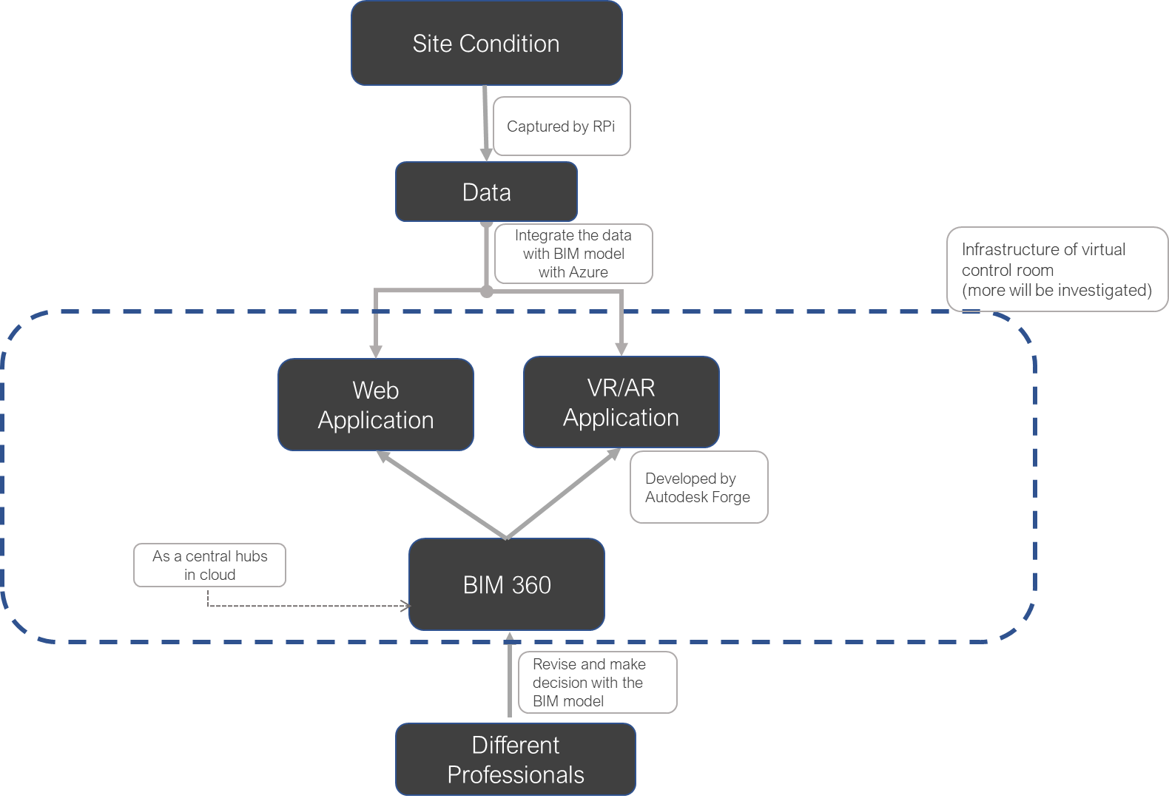

A digital twin would be built by using the Raspberry pi with Microsoft Azure as IoT Hubs, Autodesk BIM360 act as a Common Date Environment and Autodesk Forge will be used for Development (<https://www.autodesk.com/autodesk-university/article/Forge-BIM-360-Docs-IoT-Hub-2019>).

Raspberry Pi can act as microcontroller and the sensors installed on it to capture the data. (Typical sensor data such as temperature, humidity and PM2.5 will be investigated first)

BIM 360 will help to deliver the 3D model by Revit with cloud power technology such that people can access the information of the models in 3D anytime, anywhere.

The 3D model can be hosted to the cloud by using BIM 360 “Docs” components and it can be accessed in an external web/ AR/VR application developed by Unity with the development by using Autodesk Forge. Autodesk Forge is the open API of Autodesk BIM 360 where we can have access to all the tools for development and integration between Autodesk products and Microsoft Azure cloud. Microsoft Azure can act as the bridge to connect the data connected from sensors into the BIM model and delivering the sensor management.

**Site Selection**

My mother is the owner of a factory which is around 100m2 and 5m headroom and some workers are working there to manufacture hangers. The working condition of that place has high variation of temperature, air quality during the manufacturing process. I think it is a good place to simulate the construction site and I would like to build a digital twin for that place to illustrate my idea.

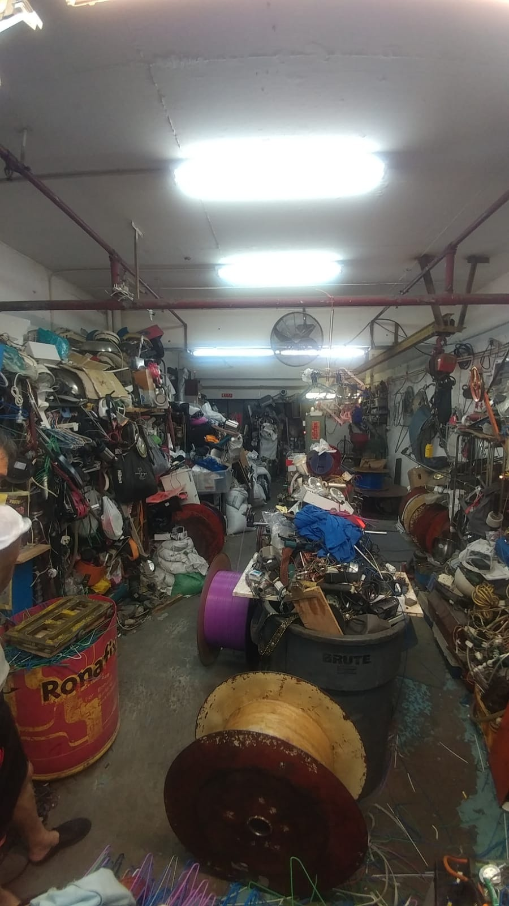

Figure Site Photo

**Limitation**

Security of Data

**Questions**

If I also try to include 3D Printing in my project, which part do you think I can use it?